CITYCOMPASS PROJECT

A PROJECT REPORT

BY

TEAM NO. - 8

GEETI (E23CSEU1891)

KASHISH (E23CSEU1900)



SUBMITTED TO

SCHOOL OF COMPUTER SCIENCE ENGINEERING AND TECHNOLOGY, BENNETT UNIVERSITY

GREATER NOIDA, 201310, UTTAR PRADESH, INDIA

April 2025

# DECLARATION

We hereby declare that the work which is being presented in the report entitled “CITY COMPASS”, is an authentic record of our own work carried out during the period from JAN, 2025 to April, 2025 at School of Computer Science and Engineering and Technology, Bennett University Greater Noida.

The matters and the results presented in this report has not been submitted by us for the award of any other degree elsewhere.

Signature of Candidate

GEETI

(Enroll. No. E23CSEU1891)

KASHISH

(Enroll. No. E23CSEU1900)

# ACKNOWLEDGEMENT

We would like to take this opportunity to express our deepest gratitude to our mentor, **Dr. Shahnawaz Ahmad** for guiding, supporting, and helping us in every possible way. We were extremely fortunate to have him as our mentor as he provided insightful solutions to problems faced by us thus contributing immensely towards the completion of this capstone project. We would also like to express our deepest gratitude to VC, DEAN, HOD, faculty members and friends who helped us in successful completion of this capstone project.

Signature of Candidate

GEETI

(Enroll. No. E23CSEU1891)

KASHISH

(Enroll. No. E23CSEU1900)

**TABLE OF CONTENTS**

LIST OF TABLES vi

LIST OF FIGURES vii

LIST OF ABBREVIATIONS viii

ABSTRACT ix

1. INTRODUCTION 1

1.1. Problem Statement 1

2. Background Research 2

2.1. Proposed System 2

2.2. Goals and Objectives 2

3. Project Planning 3

3.1. Project Lifecycle 3

3.2. Project Setup 3

3.3. Stakeholders 4

3.4. Project Resources 4

3.5. Assumptions 5

4. Project Tracking 5

4.1. Tracking 5

4.2. Communication Plan 6

4.3. Deliverables 7

5. SYSTEM ANALYSIS AND DESIGN 8

5.1. Overall Description 8

5.2. Users and Roles 8

5.3. Design diagrams/ UML diagrams/ Flow Charts/ E-R diagrams 9

5.3.1. Use Case Diagrams 9

5.3.2. Class Diagram 10

5.3.3. Activity Diagrams 11

5.3.4. Sequence Diagram 12

5.3.5. Data Architecture 13

6. User Interface 14

6.1. UI Description 14

6.2. UI Mockup 14

7. Algorithms/Pseudo Code 15

8. Project Closure 16

8.1. Goals / Vision 16

8.2. Delivered Solution 16

8.3. Remaining Work 16

REFERENCES 17

LIST OF TABLES

Table Page

Table 1: Goal and Objectives 2

Table 2: Sample 2 3

Table 3: Sample 3 4

Table 4: Sample 4 4

Table 5: Sample 4 5

Table 6: Sample 6 5

Table 7: Regularly Scheduled Meetings 6

Table 8: Information To Be Shared Within Our Group 6

Table 9: Information To Be Provided To Other Groups 6

Table 10: Information Needed From Other Groups 7

Table 11: Deliverables 7

Table 12: Sample 12 8

LIST OF FIGURES

Figure Page

Figure 1: Sample use-case diagram 9

Figure 2: sample 2 11

Figure 3: sample 3 12

Figure 4: Sample 4 13

Figure 5: Sample 5 13

Figure 6: Sample 6 14

LIST OF ABBREVIATIONS

| Abbreviation | Full Form. |

|------------------|--------------------------------------------------------|

| UI | User Interface |

| UX | User Experience |

| GPS | Global Positioning System |

| API | Application Programming Interface |

| DB | Database |

| ETA | Estimated Time of Arrival |

| CRUD | Create, Read, Update, Delete |

| SQL | Structured Query Language |

| OTP | One-Time Password |

| UXD | User Experience Design |

| JSON | JavaScript Object Notation |

| VS Code | Visual Studio Code |

| DBMS | Database Management System |

| OS | Operating System |

| MVC | Model-View-Controller |

ABSTRACT

CityCompass is a web-based transport discovery system designed to assist users in navigating unfamiliar urban environments by locating nearby transportation options such as bikes, autos, and cabs. The primary objective of this project is to develop a simple yet effective application that enables users to view available transport modes in real-time, along with essential travel details including estimated time, fare, and distance. CityCompass is built using standard web technologies — HTML and CSS for the frontend interface and SQL for backend data storage and retrieval.

The frontend offers an intuitive and visually appealing interface where users can input their current location and desired destination. The interface is structured using HTML to organize content and styled with CSS to ensure responsive design and ease of use across various devices. The backend, powered by a structured SQL database, stores critical information such as user data, vehicle types, fare rules, availability status, and location coordinates. It handles core operations like querying for nearby transport options, calculating estimated fares based on distance and type, and managing ride records.

This system operates on a modular architecture, enabling separation of concerns and ease of future expansion. While the current implementation uses predefined data to simulate live tracking and availability, the structure allows for seamless integration with real-time APIs, GPS modules, or city-specific transit data. The fare estimation is performed dynamically using logical rules stored in the database, providing users with accurate cost predictions.

CityCompass presents a reliable and accessible solution to a common problem faced by travelers and residents in unfamiliar cities. By leveraging fundamental web development and database management tools, the system demonstrates how simple technologies can be effectively combined to create functional and user-friendly transport discovery platforms. The project highlights the potential of lightweight applications to enhance urban mobility, reduce travel anxiety, and support the broader goals of smart city development.

1. INTRODUCTION

CityCompass is a web-based tool that helps users find local transport—bikes, autos, and cabs—in unfamiliar cities. It shows estimated fare, travel time, and distance based on user input. The frontend is built using HTML and CSS for a clean and responsive interface. The backend uses SQL to manage vehicles, fares, and user queries. CityCompass focuses on transport discovery, not bookings or payments. It’s simple, fast, and useful for tourists, students, and new residents.

The system is scalable for GPS or real-time data integration. It promotes easy commuting with quick, reliable transport info. This project combines basic web tools to solve real-world problems. CityCompass aims to make city travel easier and smarter.

* 1. Problem Statement

CityCompass solves many problems. Some of them are listed below:

a) Provide more personalised experienced look.

b) It simplifies fare structure, route, maps, and schedules.

c) Useful for people who recently move to a new city.

d) Easy-to-use platform.

e) It integrates various modes of transportation (buses, trains, etc.) in a single seamless system.

f) It stimulates local businesses.

1. Background Research

The literature research for CityCompass involved examining urban mobility, challenges in multi-modal transportation, and the gaps in current travel apps. Studies show a growing need for integrated solutions, as users often face difficulties in accessing real-time data across various transport modes (Vasudevan et al., 2019; Khan et al., 2020). The research highlighted the potential of real-time, multi-modal transport platforms (Chien et al., 2021), motivating the development of CityCompass as an intuitive, unified tool to simplify city navigation for newcomers.For citation management, Mendeley is recommended: [https://www.mendeley.com](https://www.mendeley.com/).

* 1. Proposed System
  2. Goals and Objectives

Table : Goal and Objectives

|  |  |
| --- | --- |
| **#** | **Goal or Objective** |
| 1 | Develop a platform that integrates at least three transport modes (bike, auto, cab) with real-time data on fares, distances, and times. |
| 2 | Ensure the system is scalable to accommodate future transport options and city expansions. |
| 3 | Provide a user-friendly interface that requires minimal training for new users. |
| 4 | Implement a reliable backend system that updates transport data in real-time to ensure accuracy. |
| 5 | Deliver a high-quality, well-documented system that can be easily supported and maintained. |

1. Project Planning

This section covers the details of the project planning. Selecting the lifecycle of the development, project stakeholders, resources required, assumptions made (if any) are detailed in the sections below.

* 1. Project Lifecycle

The CityCompass project will follow an agile lifecycle approach, with iterative development focused on continuous user feedback. The team will begin by gathering requirements and creating a high-level development plan, followed by implementing features in three major iterations. Regular SCRUM-style meetings will ensure ongoing collaboration, rapid problem-solving, and timely progress toward the final product.

* 1. Project Setup

Some of the basic project decisions that will be used on this project:

Table :

|  |  |
| --- | --- |
| **#** | **Decision Description** |
| 1 | Frontend will be developed using HTML and CSS for responsive design and accessibility. |
| 2 | Backend will utilize SQL for database management, ensuring efficient data storage and retrieval. |
| 3 | The project will follow coding standards for consistency, including the use of clear variable naming, proper commenting, and modular functions. |
| 4 | User data will be stored securely in compliance with GDPR or relevant data protection standards. |

* 1. Stakeholders

The stakeholders for this project :

Table :

|  |  |
| --- | --- |
| **Stakeholder** | **Role** |
| GEETI | Team member, Mentor |
| KASHISH | Team member, Sponser |

* 1. Project Resources

The anticipated resources required for this project :

**Example:**

Table :

|  |  |  |
| --- | --- | --- |
| **Resource** | **Resource Description** | **Quantity** |
| Development Team | Team of students responsible for designing, developing, and testing the application. | 2 |
| Database Server | QL server for storing transport data including fare, distance, and availability. | 2 |
| Transport Datasets | Real or simulated datasets with local transport details for different cities. | 1 |
| Laptops/PCs | Development machines equipped with necessary software tools (code editors, browsers). | 2 |
| HTML/CSS Frameworks | Libraries like Bootstrap or Tailwind CSS for faster and responsive UI development. | 1 |

* 1. Assumptions

Assumptions upon which the project is based :

Table :

|  |  |
| --- | --- |
| **#** | **Assumption** |
| A1 | The project team and mentor will be able to meet at least once a week for discussions and progress reviews. |
| A2 | All team members will have access to required development tools such as code editors, database software, and testing environments. |
| A3 | The transport data needed (routes, fares, timings) will be either publicly available or simulated accurately for development. |
| A4 | Team members will be able to learn and work effectively with HTML, CSS, and SQL technologies. |
| A5 | A prototype of CityCompass will be completed and functional by the end of the semester for final evaluation. |
| A6 | Internet access and hosting services will remain stable and accessible throughout the project duration. |
| A7 | The scope of the project will remain focused on locating and comparing transport modes (bike, auto, cab) without major mid-project requirement changes. |

1. Project Tracking
   1. Tracking

Table :

|  |  |
| --- | --- |
| **Information** | **Description** |
| Code Storage | Project code will be stored in SVN repository. |
| Bug Tracking | Bug tracking will be done with Trac. |

* 1. Communication Plan

Table : Regularly Scheduled Meetings

|  |  |  |
| --- | --- | --- |
| Meeting Type | Frequency/Schedule | Who Attends |
| Conference Call/Skype | Weekly | Project team |
| Team Meeting | Weekly | Project team |
| Short Meeting | Weekly during class | Project team |
| Sprint Planning Meeting | Beginning of each sprint | Project team |
| Sprint Retrospective Meeting | End of each sprint | Project team |
| Sprint Review Meeting | End of each sprint | Project team, |

Table : Information To Be Shared Within Our Group

|  |  |  |  |
| --- | --- | --- | --- |
| Who? | What Information? | When? | How? |
| Project Team | Task assignments, development progress, testing status | Weekly team meetings | Team meetings, listing in Project Specification. |
| Project Team | Code updates, feature additions | Ongoing | GitHub repository and commit messages |
| Project Team | Issues or blockers | As they arise | Team chat (WhatsApp/Slack) and meetings |

Table : Information To Be Provided To Other Groups

|  |  |  |  |
| --- | --- | --- | --- |
| Who? | What Information? | When? | How? |
| Sponsor and Mentor | Final project deliverables | At project completion | Shared via GitHub, PowerPoint, and report |
| Sponsor and Mentor | Weekly report and update reports | Weekly | Email, shared Google Drive Folder |
| Sponsor and Mentor | Sprint progress and completed features | End of each sprint | Sprint review meetings, GitHub access |

Table : Information Needed From Other Groups

|  |  |  |  |
| --- | --- | --- | --- |
| Who? | What Information? | When? | How? |
| Sponsor and Mentor | Clarification on feature requirements or changes | Start of each sprint | Conference call or meeting with sponsor and mentor. |
| Sponsor and Mentor | Feedback on demo/prototype | After sprint reviews | Sprint review meeting or shared feedback doc |

* 1. Deliverables

The major deliverables that this project is expected to produce:

Table : Deliverables

|  |  |
| --- | --- |
| **#** | **Deliverable** |
| 1 | Research and background study results, including relevant transport data sources |
| 2 | Full project source code (frontend in HTML/CSS, backend in SQL) |
| 3 | Test cases and corresponding test results for all major features |
| 4 | Build process documentation outlining setup steps for development environment |
| 5 | Installation process documentation for deploying the application on a server |
| 6 | User manual explaining how to use CityCompass features and interface |
| 7 | Postmortem document reflecting on challenges, lessons learned, and improvements |
| 8 | Final project report: includes a PowerPoint presentation, 3-minute demo video, and summary of the final sprint |

**5.** **SYSTEM ANALYSIS AND DESIGN**

This section describes in detail about the design part of the system.

* 1. Overall Description

***Project Description – CityCompass: Locating Local Transport in a New City***

CityCompass is a web-based application designed to assist individuals in navigating local transportation options when they are new to a city. It aims to provide real-time data on available transport modes—such as bikes, autos, and cabs—along with crucial details like estimated time, fare, and distance. The project integrates a SQL-based backend for storing and querying transport data and a responsive HTML/CSS frontend to ensure an intuitive user interface.

The core functionality involves filtering transport modes based on user location and preference, returning the best available options quickly and accurately. As part of development, datasets are cleaned and structured to support efficient querying and visualization. The system is designed to be scalable for different cities, with a focus on ease of use and minimal input required from users.

* 1. Users and Roles

List and description of the different types of users or roles within the system:

Table :

|  |  |
| --- | --- |
| **User** | **Description** |
| Developer | A team member involved in building, testing, and maintaining the system. Works on both frontend and backend components and ensures smooth data integration. |
| End User (Traveler) | A person new to the city who uses CityCompass to discover local transport options such as bikes, autos, or cabs. They input their current location and desired destination to receive optimal transport suggestions based on fare, time, and distance. |
| Data Provider Agent | A system role or external API that feeds CityCompass with real-time or periodic data regarding local transport availability, pricing, and routes. |

* 1. Design diagrams/Architecture/ UML diagrams/ Flow Charts/ E-R diagrams

**USE CASE DIAGRAM :**

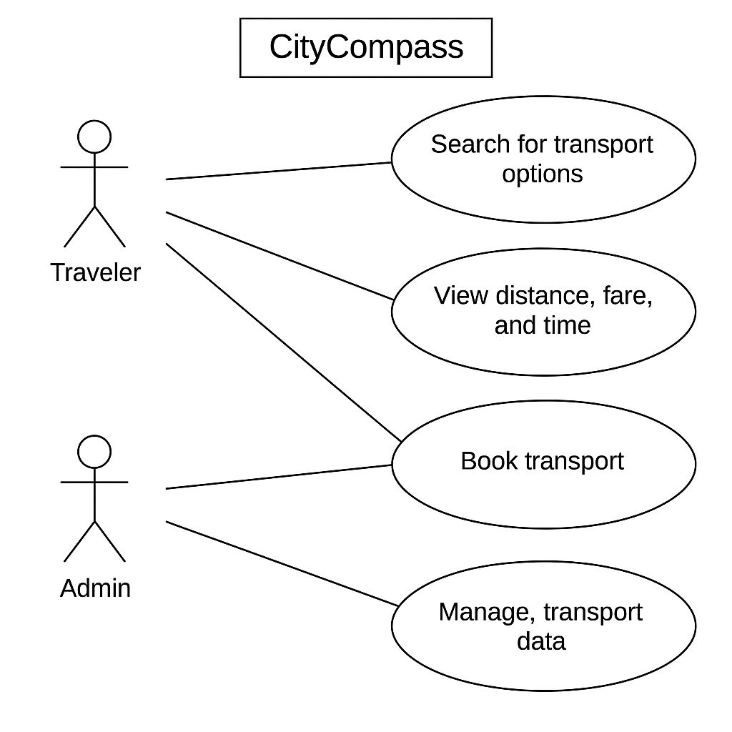

**FLOW CHART :**

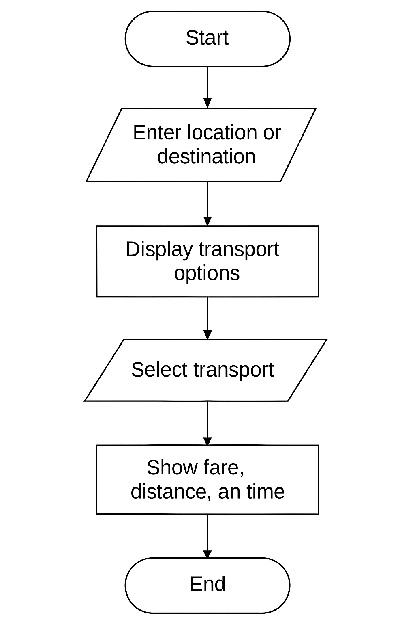

* + 1. Product Backlog Items

All our functionalities/requirements as user-stories in the format are listed below:

1. As a city newcomer, I want to search for nearby transport options (bike, auto, cab) so that I can choose the most convenient one to reach my destination.

2. As a city newcomer, I want to see the estimated time, fare, and distance for each transport option so that I can make an informed decision.

3. As a user, I want to view the transport options sorted by proximity to my current location so that I can easily find the nearest available option.

4. As a user, I want to filter transport options based on my preferences (bike, auto, cab) so that I can choose the mode of transport I prefer.

5. As a user, I want to compare transport options based on fare, time, and distance so that I can choose the best value option.

6. As a frequent traveler, I want to save my preferred transport mode so that I can quickly access it in future searches.

7. As a user, I want to receive real-time updates on my selected transport options (e.g., availability, traffic conditions) so that I can plan my trip more effectively.

8. As a city resident, I want to rate transport options based on my experience so that I can share feedback with other users and improve the service.

9. As a user, I want to view a map showing the transport options and their routes so that I can visualize the journey and plan accordingly.

10. As a tourist, I want to get recommendations for popular transport routes so that I can easily navigate the city.

* + 1. Architecture Diagram

The architecture diagram for your product :

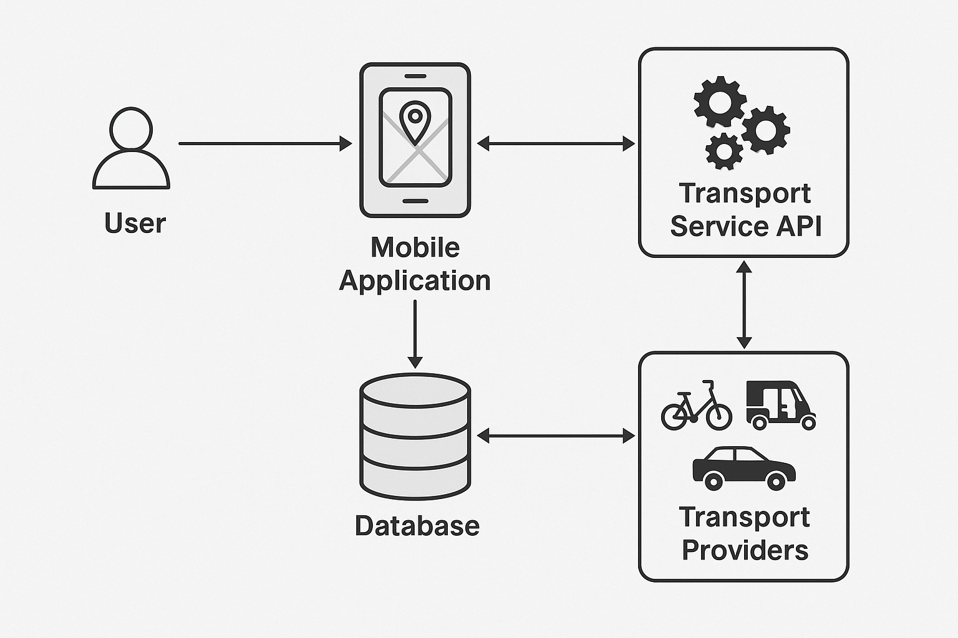

* + 1. Use Case Diagram

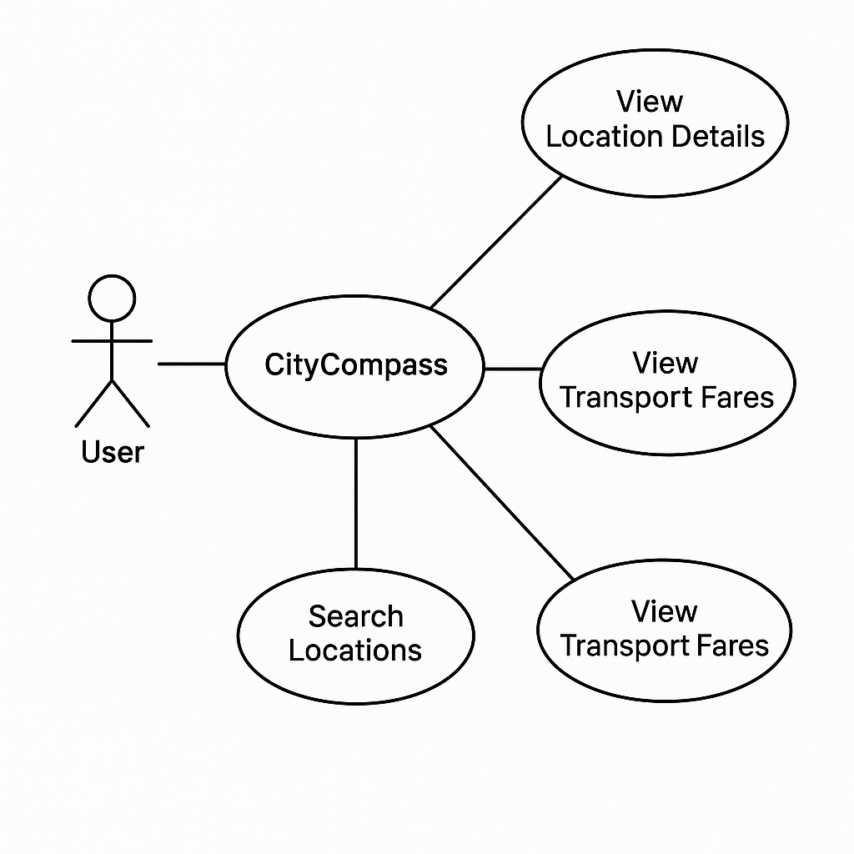

* + 1. Class Diagram

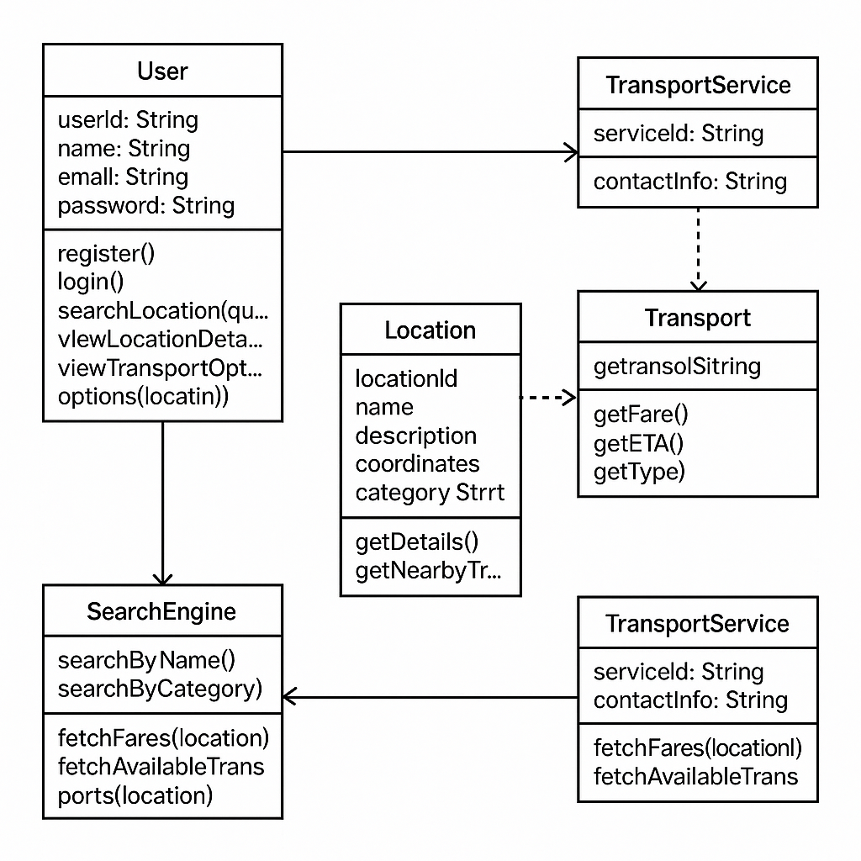

* + 1. Activity Diagram

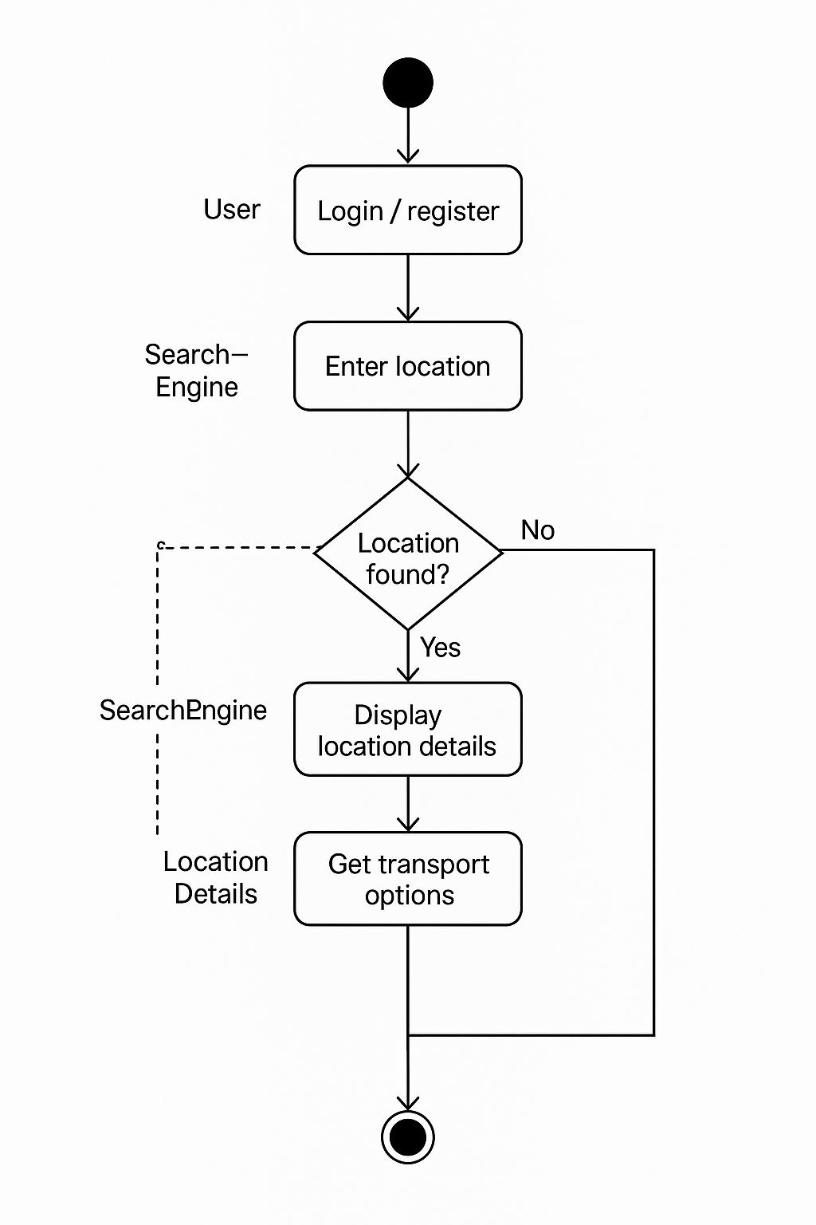

* + 1. Sequence Diagram

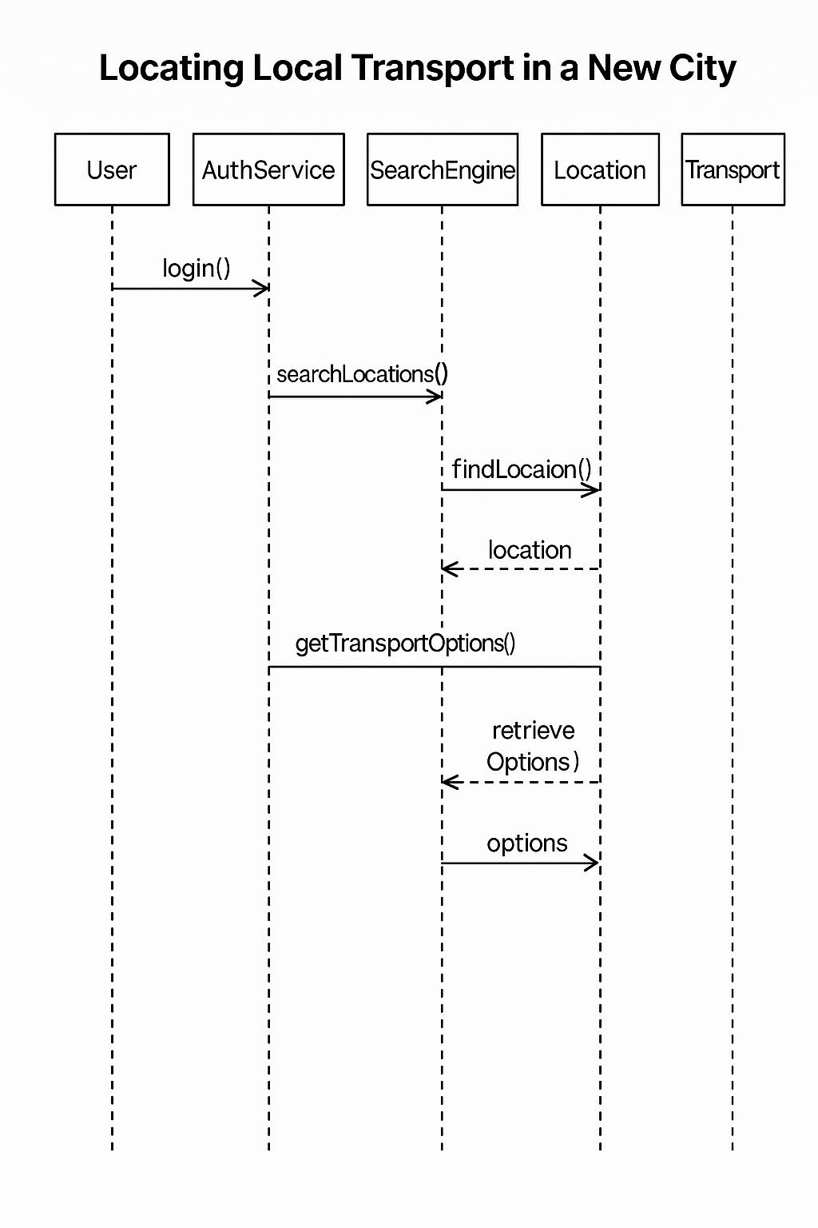

* + 1. Data Architecture

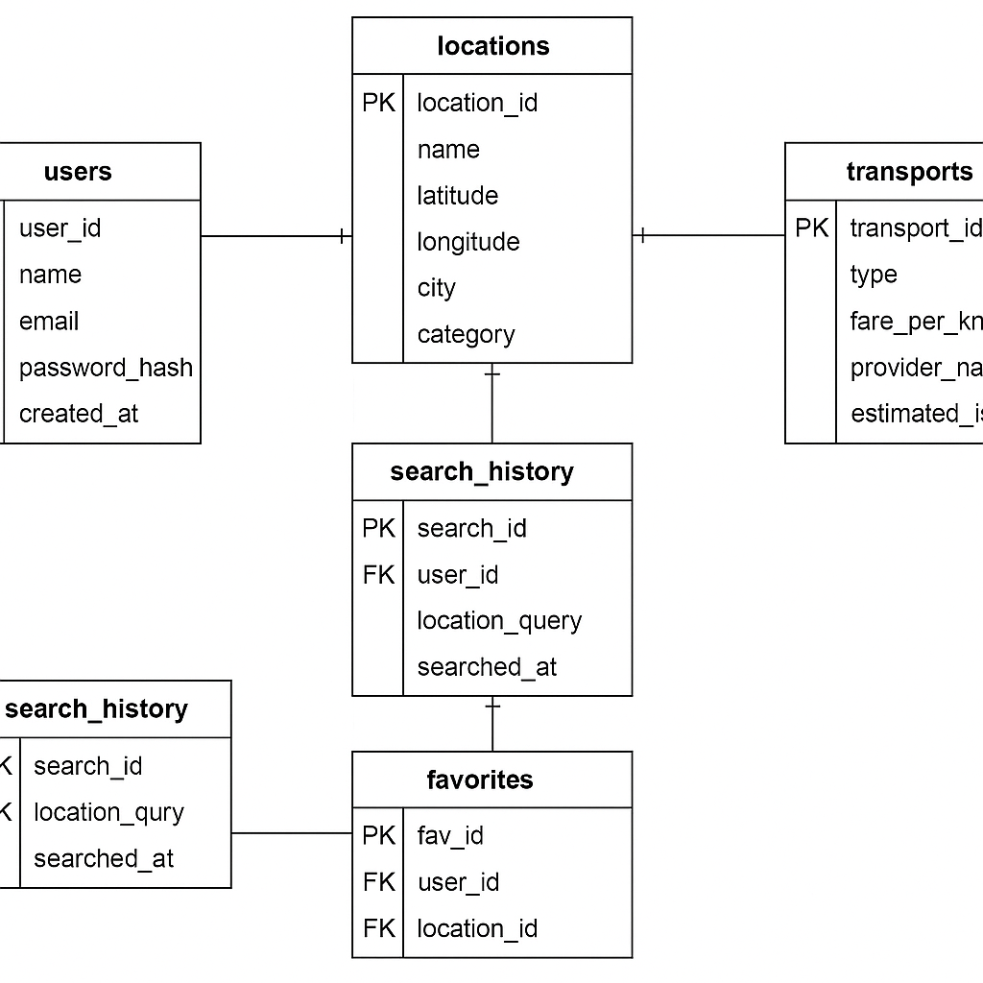

1. User Interface
   1. UI Description

A brief description of the UI that will be used in this program and how users will interact with the program:

The CityCompass project will feature a responsive and user-friendly graphical user interface (GUI), designed primarily for mobile devices but also accessible via web browsers. The UI will allow users to interact seamlessly with the system to locate nearby transportation options within unfamiliar cities.

The main components of the UI include:

1. Login & Registration Screen - Users will be able to sign up or log in using their email and password. This screen will include basic form fields and validation prompts.
2. Home/Search Screen - After logging in, users will be presented with a search bar and current location access. They can enter a location or allow GPS to detect their position.
3. Location Details View - Once a location is selected, the interface will display key information such as name, description, category, and map preview.
4. Transport Options Screen - Users will see available transport types (cab, bike, auto) along with fare estimates, provider names, and estimated arrival times. This data will be presented in card-style layouts for easy comparison.
5. Favorites and History Section - Users can save favorite locations and view past searches via a simple tab interface.
6. Navigation and Layout - Navigation will follow a bottom tab or side drawer style, depending on the platform. The design will focus on intuitive icons, minimalistic color themes, and accessibility considerations.

The entire UI is being developed using **React Native** (or Flutter, if preferred), which supports cross-platform development and delivers a smooth mobile experience. Any backend interaction (searching locations, retrieving transport options, logging in) will be handled via API calls, abstracted behind user-friendly UI components.

* 1. UI Mockup

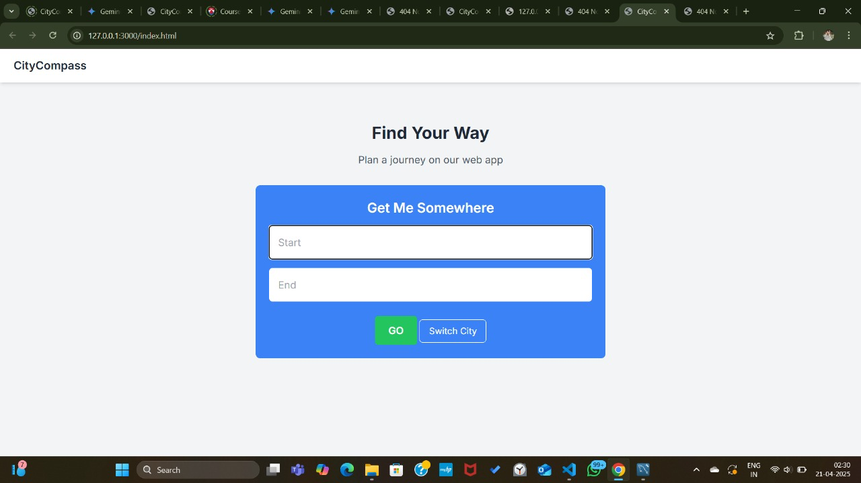

1. Algorithms/Pseudo Code OF CORE FUNCTIONALITY

**Function: LocateTransportOptions –**

FUNCTION LocateTransportOptions(userLocation):

IF userLocation IS NULL:

userLocation ← GET_CURRENT_GPS_LOCATION()

location←SEARCH_LOCATION_IN_DATABASE(userLocation)

IF location IS NOT FOUND:

DISPLAY "No matching location found."

RETURN

DISPLAY_LOCATION_DETAILS(location)

transportOptions ← FETCH_TRANSPORT_BY_LOCATION_ID(location.id)

IF transportOptions IS EMPTY:

DISPLAY "No transport options available."

RETURN

FOR each transport IN transportOptions:

fare ← CALCULATE_FARE(transport.type, userLocation, location.coordinates)

ETA ← ESTIMATE_ARRIVAL_TIME(transport.provider, userLocation)

DISPLAY_TRANSPORT_CARD(transport.type, fare, ETA, transport.provider)

**Helper Function: SEARCH_LOCATION_IN_DATABASE:**

FUNCTION SEARCH_LOCATION_IN_DATABASE(query):

RETURN SELECT * FROM Locations WHERE name LIKE query OR coordinates NEAR query

1. Project Closure
   1. Goals / Vision

The vision of the City Compass project is to help users locate and compare local transport options like cabs, bikes, and autos in unfamiliar cities. Initially focused on location-based search and fare visibility, the project evolved to include user login, favorites, and search history. It aims to provide a smooth and informative user experience through a clean mobile/web UI. The system is built to be scalable and support future enhancements. Ultimately, CityCompass empowers travelers to make smart, informed transport decisions in any city.

* 1. Delivered Solution

The CityCompass project set out to build a platform to help users find and compare local transport options in new cities. The delivered solution includes a functional web/mobile app with user authentication, location search, and transport fare display. Users can save favorite locations and view search history. The system features a clean UI and a scalable backend to support new services. Overall, it provides a reliable and intuitive experience for navigating unfamiliar cities.

* 1. Remaining Work

The current CityCompass solution can be improved by integrating real-time traffic and availability data from transport providers. Adding booking functionality and multi-language support would enhance user convenience and accessibility. Further UI refinement and performance optimization are also recommended. Expanding coverage to more cities and regions will increase usability. Lastly, implementing AI-based transport recommendations can make the system smarter and more personalized.

REFERENCES

• **Google Maps Platform** – Used for location data, geocoding, and mapping services.  
https://developers.google.com/maps

• **Kaggle Datasets** – Sourced sample datasets for city transport data and fare estimation.  
[https://www.kaggle.com](https://www.kaggle.com/)

• **Visual Studio Code** – Primary code editor and development environment.  
[https://code.visualstudio.com](https://code.visualstudio.com/)

• **MySQL / SQL** – Used for database schema design, queries, and data storage.  
[https://www.mysql.com](https://www.mysql.com/)

• **React Native (or Flutter)** – For building the cross-platform mobile application interface.  
[https://reactnative.dev](https://reactnative.dev/) / [https://flutter.dev](https://flutter.dev/)

• **Stack Overflow** – Referenced for resolving development issues and implementation examples.  
[https://stackoverflow.com](https://stackoverflow.com/)